ASSESSMENT TOOL 1 – High (Coding Challenge)

1. Library Book Management using Classes &amp; Encapsulation
import java.util.Scanner;

class Book {
private int bookId;
private String title;
private String author;
private double price;
private boolean issued;

public Book(int bookId, String title, String author, double price) {
this.bookId = bookId;
this.title = title;
this.author = author;
this.price = price;
this.issued = false;
}

public int getBookId() {
return bookId;
}

public String getTitle() {
return title;
}

public String getAuthor() {
return author;
}

public double getPrice() {
return price;
}

public boolean isIssued() {
return issued;
}

public void setTitle(String title) {
this.title = title;
}

public void setAuthor(String author) {
this.author = author;
}

public void setPrice(double price) {
if (price > 0)
this.price = price;
}

public void issueBook() {
if (!issued) {
issued = true;
System.out.println("Book Issued Successfully.");
} else {
System.out.println("Book is Already Issued.");
}
}

public void returnBook() {
if (issued) {
issued = false;
System.out.println("Book Returned Successfully.");
} else {
System.out.println("Book was Not Issued.");
}
}

public void displayBook() {
System.out.println("-----------------------------------");
System.out.println("Book ID : " + bookId);
System.out.println("Title : " + title);
System.out.println("Author : " + author);
System.out.println("Price : " + price);
System.out.println("Status : " + (issued ? "Issued" : "Available"));
}
}

public class LibraryBookManagement {

static Scanner sc = new Scanner(System.in);
static Book[] books = new Book[100];
static int count = 0;

public static int searchBook(int id) {
for (int i = 0; i < count; i++) {
if (books[i].getBookId() == id)
return i;
}
return -1;
}

public static void addBook() {
System.out.print("Enter Book ID: ");
int id = sc.nextInt();

if (searchBook(id) != -1) {
System.out.println("Book ID Already Exists.");
return;
}

sc.nextLine();

System.out.print("Enter Title: ");
String title = sc.nextLine();

System.out.print("Enter Author: ");
String author = sc.nextLine();

System.out.print("Enter Price: ");
double price = sc.nextDouble();

books[count++] = new Book(id, title, author, price);

System.out.println("Book Added Successfully.");
}

public static void displayBooks() {
if (count == 0) {
System.out.println("No Books Available.");
return;
}

for (int i = 0; i < count; i++) {
books[i].displayBook();
}
}

public static void search() {
System.out.print("Enter Book ID: ");
int id = sc.nextInt();

int index = searchBook(id);

if (index != -1)
books[index].displayBook();
else
System.out.println("Book Not Found.");
}

public static void issueBook() {
System.out.print("Enter Book ID: ");
int id = sc.nextInt();

int index = searchBook(id);

if (index != -1)
books[index].issueBook();
else
System.out.println("Book Not Found.");
}

public static void returnBook() {
System.out.print("Enter Book ID: ");
int id = sc.nextInt();

int index = searchBook(id);

if (index != -1)
books[index].returnBook();
else
System.out.println("Book Not Found.");
}

public static void main(String[] args) {

int choice;

do {
System.out.println("\n===== LIBRARY BOOK MANAGEMENT =====");
System.out.println("1. Add Book");
System.out.println("2. Display Books");
System.out.println("3. Search Book");
System.out.println("4. Issue Book");
System.out.println("5. Return Book");
System.out.println("6. Exit");
System.out.print("Enter Choice: ");

choice = sc.nextInt();

switch (choice) {
case 1:
addBook();
break;

case 2:
displayBooks();
break;

case 3:
search();
break;

case 4:
issueBook();
break;

case 5:
returnBook();
break;

case 6:
System.out.println("Thank You!");
break;

default:
System.out.println("Invalid Choice.");
}

} while (choice != 6);

sc.close();
}
}

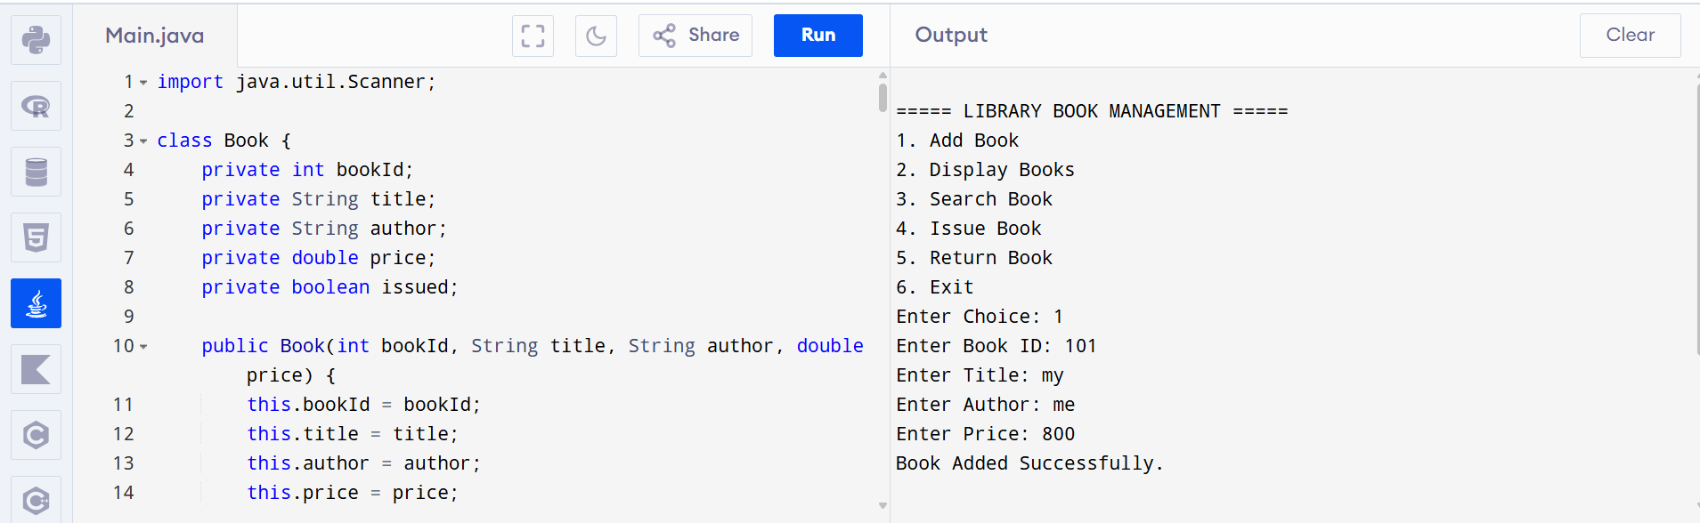

2. Employee Payroll System using Inheritance

import java.util.Scanner;

class Employee {
protected int empId;
protected String name;

Employee(int empId, String name) {
this.empId = empId;
this.name = name;
}

public double calculateSalary() {
return 0;
}

public void display() {
System.out.println("\nEmployee ID : " + empId);
System.out.println("Employee Name : " + name);
System.out.println("Salary : " + calculateSalary());
}
}

class PermanentEmployee extends Employee {
private double basicSalary;
private double hra;
private double da;

PermanentEmployee(int empId, String name, double basicSalary, double hra, double da) {
super(empId, name);
this.basicSalary = basicSalary;
this.hra = hra;
this.da = da;
}

@Override
public double calculateSalary() {
return basicSalary + hra + da;
}
}

class ContractEmployee extends Employee {
private int hoursWorked;
private double ratePerHour;

ContractEmployee(int empId, String name, int hoursWorked, double ratePerHour) {
super(empId, name);
this.hoursWorked = hoursWorked;
this.ratePerHour = ratePerHour;
}

@Override
public double calculateSalary() {
return hoursWorked * ratePerHour;
}
}

public class Main {

public static void main(String[] args) {

Scanner sc = new Scanner(System.in);

Employee[] employees = new Employee[10];
int count = 0;
int choice;

do {
System.out.println("\n===== EMPLOYEE PAYROLL SYSTEM =====");
System.out.println("1. Add Permanent Employee");
System.out.println("2. Add Contract Employee");
System.out.println("3. Display All Employees");
System.out.println("4. Exit");
System.out.print("Enter Choice: ");
choice = sc.nextInt();

switch (choice) {

case 1:
System.out.print("Enter Employee ID: ");
int pid = sc.nextInt();
sc.nextLine();

System.out.print("Enter Employee Name: ");
String pname = sc.nextLine();

System.out.print("Enter Basic Salary: ");
double basic = sc.nextDouble();

System.out.print("Enter HRA: ");
double hra = sc.nextDouble();

System.out.print("Enter DA: ");
double da = sc.nextDouble();

employees[count++] = new PermanentEmployee(pid, pname, basic, hra, da);

System.out.println("Permanent Employee Added Successfully.");
break;

case 2:
System.out.print("Enter Employee ID: ");
int cid = sc.nextInt();
sc.nextLine();

System.out.print("Enter Employee Name: ");
String cname = sc.nextLine();

System.out.print("Enter Hours Worked: ");
int hours = sc.nextInt();

System.out.print("Enter Rate Per Hour: ");
double rate = sc.nextDouble();

employees[count++] = new ContractEmployee(cid, cname, hours, rate);

System.out.println("Contract Employee Added Successfully.");
break;

case 3:
if (count == 0) {
System.out.println("No Employees Found.");
} else {
System.out.println("\n===== EMPLOYEE DETAILS =====");
for (int i = 0; i < count; i++) {
employees[i].display();
}
}
break;

case 4:
System.out.println("Thank You!");
break;

default:
System.out.println("Invalid Choice.");
}

} while (choice != 4);

sc.close();
}
}

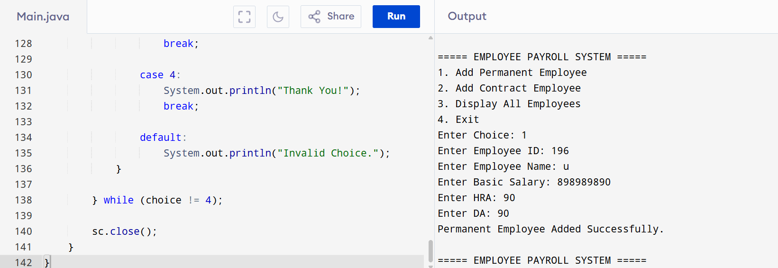

3. Vehicle Rental System using Runtime Polymorphism

import java.util.Scanner;

class Vehicle {
protected String vehicleNo;
protected String model;

Vehicle(String vehicleNo, String model) {
this.vehicleNo = vehicleNo;
this.model = model;
}

public double calculateRent(int days) {
return 0;
}

public void display(int days) {
System.out.println("\nVehicle Number : " + vehicleNo);
System.out.println("Model : " + model);
System.out.println("Rental Days : " + days);
System.out.println("Total Rent : Rs. " + calculateRent(days));
}
}

class Car extends Vehicle {
private static final double RENT_PER_DAY = 1500;

Car(String vehicleNo, String model) {
super(vehicleNo, model);
}

@Override
public double calculateRent(int days) {
return days * RENT_PER_DAY;
}
}

class Bike extends Vehicle {
private static final double RENT_PER_DAY = 500;

Bike(String vehicleNo, String model) {
super(vehicleNo, model);
}

@Override
public double calculateRent(int days) {
return days * RENT_PER_DAY;
}
}

class Bus extends Vehicle {
private static final double RENT_PER_DAY = 3000;

Bus(String vehicleNo, String model) {
super(vehicleNo, model);
}

@Override
public double calculateRent(int days) {
return days * RENT_PER_DAY;
}
}

public class Main {

public static void main(String[] args) {

Scanner sc = new Scanner(System.in);

Vehicle[] vehicles = new Vehicle[10];
int count = 0;
int choice;

do {
System.out.println("\n===== VEHICLE RENTAL SYSTEM =====");
System.out.println("1. Add Car");
System.out.println("2. Add Bike");
System.out.println("3. Add Bus");
System.out.println("4. Generate Rental Bill");
System.out.println("5. Exit");
System.out.print("Enter Choice: ");
choice = sc.nextInt();

switch (choice) {

case 1:
sc.nextLine();
System.out.print("Enter Vehicle Number: ");
String carNo = sc.nextLine();

System.out.print("Enter Car Model: ");
String carModel = sc.nextLine();

vehicles[count++] = new Car(carNo, carModel);
System.out.println("Car Added Successfully.");
break;

case 2:
sc.nextLine();
System.out.print("Enter Vehicle Number: ");
String bikeNo = sc.nextLine();

System.out.print("Enter Bike Model: ");
String bikeModel = sc.nextLine();

vehicles[count++] = new Bike(bikeNo, bikeModel);
System.out.println("Bike Added Successfully.");
break;

case 3:
sc.nextLine();
System.out.print("Enter Vehicle Number: ");
String busNo = sc.nextLine();

System.out.print("Enter Bus Model: ");
String busModel = sc.nextLine();

vehicles[count++] = new Bus(busNo, busModel);
System.out.println("Bus Added Successfully.");
break;

case 4:
if (count == 0) {
System.out.println("No Vehicles Available.");
break;
}

System.out.println("\n===== RENTAL BILLS =====");

for (int i = 0; i < count; i++) {
System.out.print("\nEnter Rental Days for Vehicle "
+ (i + 1) + " (" + vehicles[i].vehicleNo + "): ");
int days = sc.nextInt();
vehicles[i].display(days);
}
break;

case 5:
System.out.println("Thank You!");
break;

default:
System.out.println("Invalid Choice!");
}

} while (choice != 5);

sc.close();
}
}
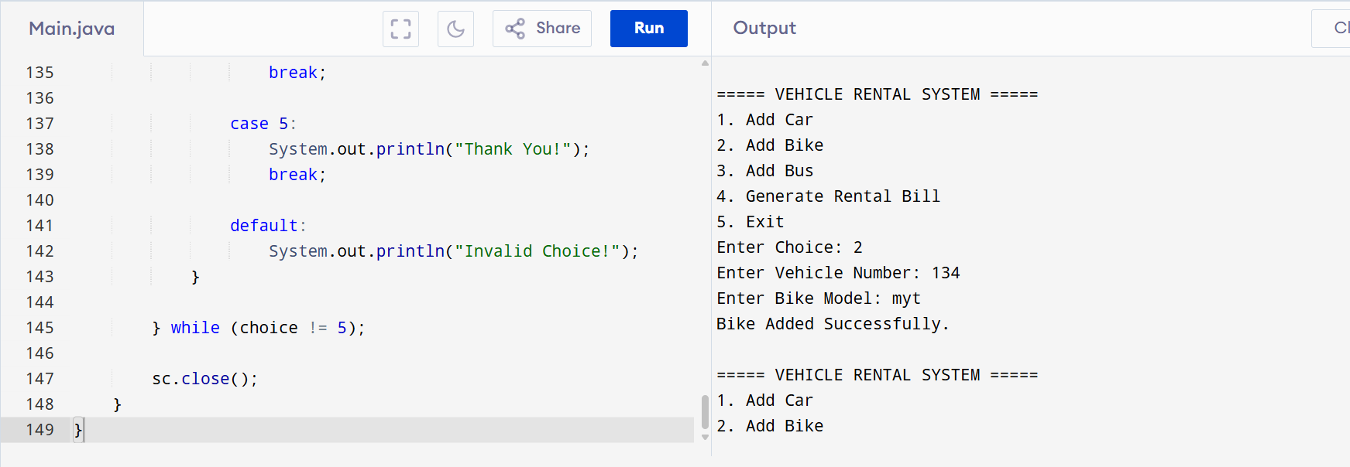

4. Bank Account System using Data Hiding
import java.util.Scanner;

class BankAccount {
private int accountNumber;
private String holderName;
private double balance;

// Constructor
BankAccount(int accountNumber, String holderName, double balance) {
this.accountNumber = accountNumber;
this.holderName = holderName;
this.balance = balance;
}

// Getters
public int getAccountNumber() {
return accountNumber;
}

public String getHolderName() {
return holderName;
}

public double getBalance() {
return balance;
}

// Deposit Method
public void deposit(double amount) {
if (amount > 0) {
balance += amount;
System.out.println("Amount Deposited Successfully.");
} else {
System.out.println("Invalid Deposit Amount.");
}
}

// Withdraw Method
public void withdraw(double amount) {
if (amount <= 0) {
System.out.println("Invalid Withdrawal Amount.");
} else if (amount > balance) {
System.out.println("Insufficient Balance.");
} else {
balance -= amount;
System.out.println("Amount Withdrawn Successfully.");
}
}

// Display Account Details
public void display() {
System.out.println("\n===== ACCOUNT DETAILS =====");
System.out.println("Account Number : " + accountNumber);
System.out.println("Holder Name : " + holderName);
System.out.println("Balance : Rs. " + balance);
}
}

public class Main {

public static void main(String[] args) {

Scanner sc = new Scanner(System.in);

System.out.print("Enter Account Number: ");
int accNo = sc.nextInt();
sc.nextLine();

System.out.print("Enter Account Holder Name: ");
String name = sc.nextLine();

System.out.print("Enter Initial Balance: ");
double balance = sc.nextDouble();

BankAccount account = new BankAccount(accNo, name, balance);

int choice;

do {
System.out.println("\n===== BANK ACCOUNT SYSTEM =====");
System.out.println("1. Deposit");
System.out.println("2. Withdraw");
System.out.println("3. Balance Inquiry");
System.out.println("4. Exit");
System.out.print("Enter Choice: ");

choice = sc.nextInt();

switch (choice) {

case 1:
System.out.print("Enter Deposit Amount: ");
double deposit = sc.nextDouble();
account.deposit(deposit);
break;

case 2:
System.out.print("Enter Withdrawal Amount: ");
double withdraw = sc.nextDouble();
account.withdraw(withdraw);
break;

case 3:
account.display();
break;

case 4:
System.out.println("Thank You!");
break;

default:
System.out.println("Invalid Choice.");
}

} while (choice != 4);

sc.close();
}
}
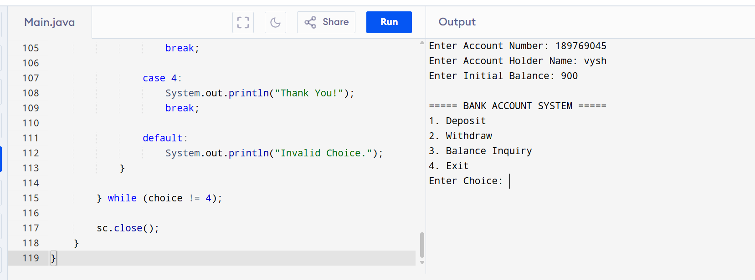

5. University Admission System using Method Overloading
import java.util.Scanner;

class Admission {

// Undergraduate Fee
public void calculateFee() {
double fee = 50000;
System.out.println("\nStudent Type : Undergraduate");
System.out.println("Course Fee : Rs. " + fee);
}

// Postgraduate Fee
public void calculateFee(String course) {
double fee = 80000;
System.out.println("\nStudent Type : Postgraduate");
System.out.println("Course : " + course);
System.out.println("Course Fee : Rs. " + fee);
}

// Scholarship Student Fee
public void calculateFee(String course, double scholarshipPercent) {
double fee = 80000;
double finalFee = fee - (fee * scholarshipPercent / 100);

System.out.println("\nStudent Type : Scholarship Student");
System.out.println("Course : " + course);
System.out.println("Scholarship (%) : " + scholarshipPercent);
System.out.println("Final Course Fee : Rs. " + finalFee);
}
}

public class Main {

public static void main(String[] args) {

Scanner sc = new Scanner(System.in);
Admission admission = new Admission();

int choice;

do {
System.out.println("\n===== UNIVERSITY ADMISSION SYSTEM =====");
System.out.println("1. Undergraduate Student");
System.out.println("2. Postgraduate Student");
System.out.println("3. Scholarship Student");
System.out.println("4. Exit");
System.out.print("Enter Choice: ");

choice = sc.nextInt();
sc.nextLine();

switch (choice) {

case 1:
admission.calculateFee();
break;

case 2:
System.out.print("Enter PG Course Name: ");
String pgCourse = sc.nextLine();
admission.calculateFee(pgCourse);
break;

case 3:
System.out.print("Enter Course Name: ");
String course = sc.nextLine();

System.out.print("Enter Scholarship Percentage: ");
double scholarship = sc.nextDouble();

admission.calculateFee(course, scholarship);
break;

case 4:
System.out.println("Thank You!");
break;

default:
System.out.println("Invalid Choice.");
}

} while (choice != 4);

sc.close();
}
}
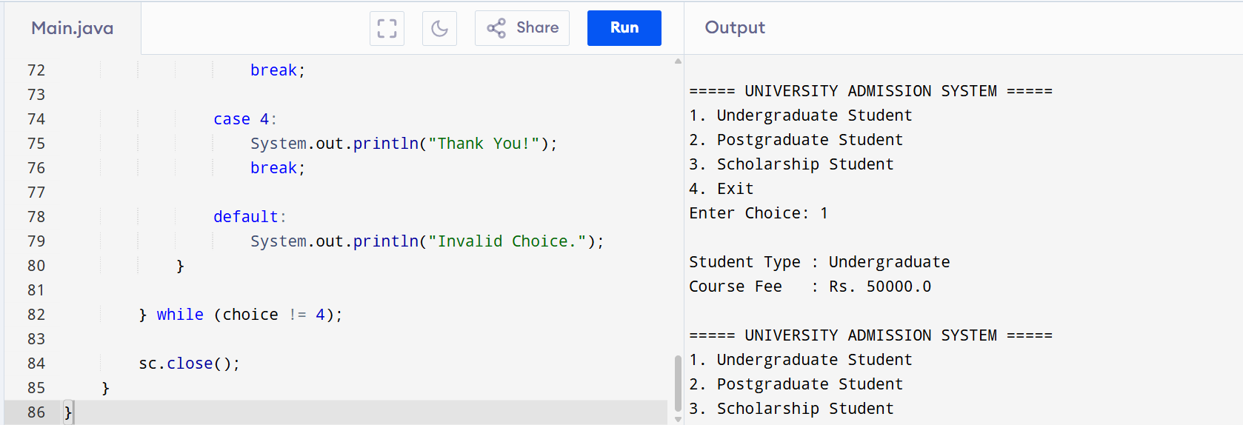

6. Shape Area Calculator using Abstract Class &amp; Polymorphism
import java.util.Scanner;

// Abstract Class
abstract class Shape {

public abstract double area();

public abstract void display();
}

// Circle Class
class Circle extends Shape {
private double radius;

Circle(double radius) {
this.radius = radius;
}

@Override
public double area() {
return Math.PI * radius * radius;
}

@Override
public void display() {
System.out.println("\nShape : Circle");
System.out.println("Radius : " + radius);
System.out.printf("Area : %.2f\n", area());
}
}

// Rectangle Class
class Rectangle extends Shape {
private double length;
private double breadth;

Rectangle(double length, double breadth) {
this.length = length;
this.breadth = breadth;
}

@Override
public double area() {
return length * breadth;
}

@Override
public void display() {
System.out.println("\nShape : Rectangle");
System.out.println("Length : " + length);
System.out.println("Breadth : " + breadth);
System.out.printf("Area : %.2f\n", area());
}
}

// Triangle Class
class Triangle extends Shape {
private double base;
private double height;

Triangle(double base, double height) {
this.base = base;
this.height = height;
}

@Override
public double area() {
return 0.5 * base * height;
}

@Override
public void display() {
System.out.println("\nShape : Triangle");
System.out.println("Base : " + base);
System.out.println("Height : " + height);
System.out.printf("Area : %.2f\n", area());
}
}

// Main Class
public class Main {

public static void main(String[] args) {

Scanner sc = new Scanner(System.in);

Shape[] shapes = new Shape[20];
int count = 0;
int choice;

do {
System.out.println("\n===== SHAPE AREA CALCULATOR =====");
System.out.println("1. Add Circle");
System.out.println("2. Add Rectangle");
System.out.println("3. Add Triangle");
System.out.println("4. Display Areas");
System.out.println("5. Exit");
System.out.print("Enter Choice: ");
choice = sc.nextInt();

switch (choice) {

case 1:
System.out.print("Enter Radius: ");
double radius = sc.nextDouble();
shapes[count++] = new Circle(radius);
System.out.println("Circle Added Successfully.");
break;

case 2:
System.out.print("Enter Length: ");
double length = sc.nextDouble();

System.out.print("Enter Breadth: ");
double breadth = sc.nextDouble();

shapes[count++] = new Rectangle(length, breadth);
System.out.println("Rectangle Added Successfully.");
break;

case 3:
System.out.print("Enter Base: ");
double base = sc.nextDouble();

System.out.print("Enter Height: ");
double height = sc.nextDouble();

shapes[count++] = new Triangle(base, height);
System.out.println("Triangle Added Successfully.");
break;

case 4:
if (count == 0) {
System.out.println("No Shapes Available.");
} else {
System.out.println("\n===== SHAPE DETAILS =====");
for (int i = 0; i < count; i++) {
shapes[i].display(); // Runtime Polymorphism
}
}
break;

case 5:
System.out.println("Thank You!");
break;

default:
System.out.println("Invalid Choice.");
}

} while (choice != 5);

sc.close();
}
}
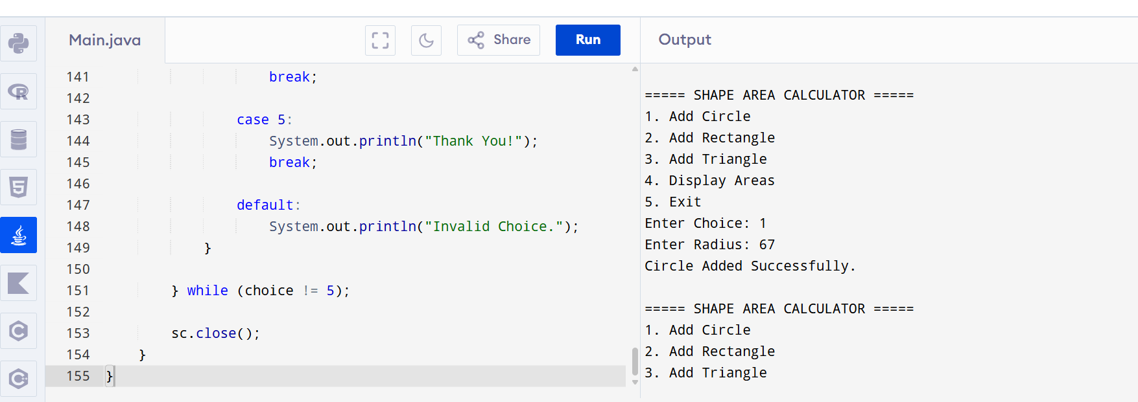

7. Hospital Management System using Interfaces
import java.util.Scanner;

// Interface
interface MedicalRecord {
void addRecord();
void displayRecord();
}

// Patient Class
class Patient implements MedicalRecord {
private int patientId;
private String patientName;
private String disease;

Scanner sc = new Scanner(System.in);

@Override
public void addRecord() {
System.out.print("Enter Patient ID: ");
patientId = sc.nextInt();
sc.nextLine();

System.out.print("Enter Patient Name: ");
patientName = sc.nextLine();

System.out.print("Enter Disease: ");
disease = sc.nextLine();
}

@Override
public void displayRecord() {
System.out.println("\n===== PATIENT RECORD =====");
System.out.println("Patient ID : " + patientId);
System.out.println("Patient Name : " + patientName);
System.out.println("Disease : " + disease);
}
}

// Doctor Class
class Doctor implements MedicalRecord {
private int doctorId;
private String doctorName;
private String specialization;

Scanner sc = new Scanner(System.in);

@Override
public void addRecord() {
System.out.print("Enter Doctor ID: ");
doctorId = sc.nextInt();
sc.nextLine();

System.out.print("Enter Doctor Name: ");
doctorName = sc.nextLine();

System.out.print("Enter Specialization: ");
specialization = sc.nextLine();
}

@Override
public void displayRecord() {
System.out.println("\n===== DOCTOR RECORD =====");
System.out.println("Doctor ID : " + doctorId);
System.out.println("Doctor Name : " + doctorName);
System.out.println("Specialization : " + specialization);
}
}

// Main Class
public class Main {

public static void main(String[] args) {

Scanner sc = new Scanner(System.in);

Patient patient = new Patient();
Doctor doctor = new Doctor();

int choice;

do {
System.out.println("\n===== HOSPITAL MANAGEMENT SYSTEM =====");
System.out.println("1. Add Patient Record");
System.out.println("2. Display Patient Record");
System.out.println("3. Add Doctor Record");
System.out.println("4. Display Doctor Record");
System.out.println("5. Exit");
System.out.print("Enter Choice: ");

choice = sc.nextInt();

switch (choice) {

case 1:
patient.addRecord();
break;

case 2:
patient.displayRecord();
break;

case 3:
doctor.addRecord();
break;

case 4:
doctor.displayRecord();
break;

case 5:
System.out.println("Thank You!");
break;

default:
System.out.println("Invalid Choice.");
}

} while (choice != 5);

sc.close();
}
}
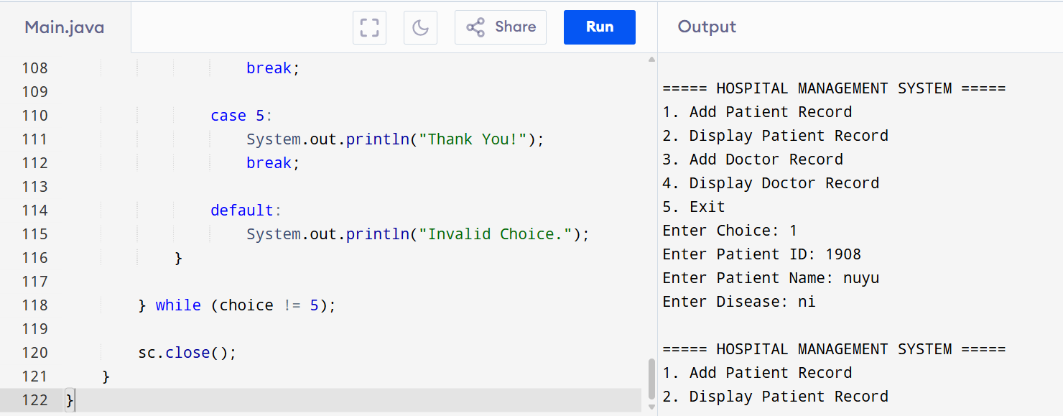
8. Online Shopping Order System using Packages
import java.util.Scanner;

class Product {
private int productId;
private String productName;
private double price;

public Product(int productId, String productName, double price) {
this.productId = productId;
this.productName = productName;
this.price = price;
}

public double getPrice() {
return price;
}

public void displayProduct() {
System.out.println("\nProduct ID : " + productId);
System.out.println("Product Name : " + productName);
System.out.println("Price : Rs. " + price);
}
}

class Order {
private Product product;
private int quantity;

public Order(Product product, int quantity) {
this.product = product;
this.quantity = quantity;
}

public double calculateTotal() {
return product.getPrice() * quantity;
}

public void displayBill() {
System.out.println("\n===== ORDER BILL =====");
product.displayProduct();
System.out.println("Quantity : " + quantity);
System.out.println("Total Amount : Rs. " + calculateTotal());
}
}

public class Main {
public static void main(String[] args) {

Scanner sc = new Scanner(System.in);

int choice;

do {
System.out.println("\n===== ONLINE SHOPPING ORDER SYSTEM =====");
System.out.println("1. Place Order");
System.out.println("2. Exit");
System.out.print("Enter Choice: ");
choice = sc.nextInt();

switch (choice) {

case 1:
System.out.print("Enter Product ID: ");
int id = sc.nextInt();
sc.nextLine();

System.out.print("Enter Product Name: ");
String name = sc.nextLine();

System.out.print("Enter Product Price: ");
double price = sc.nextDouble();

System.out.print("Enter Quantity: ");
int quantity = sc.nextInt();

Product product = new Product(id, name, price);
Order order = new Order(product, quantity);

order.displayBill();
break;

case 2:
System.out.println("Thank You!");
break;

default:
System.out.println("Invalid Choice.");
}

} while (choice != 2);

sc.close();
}
}
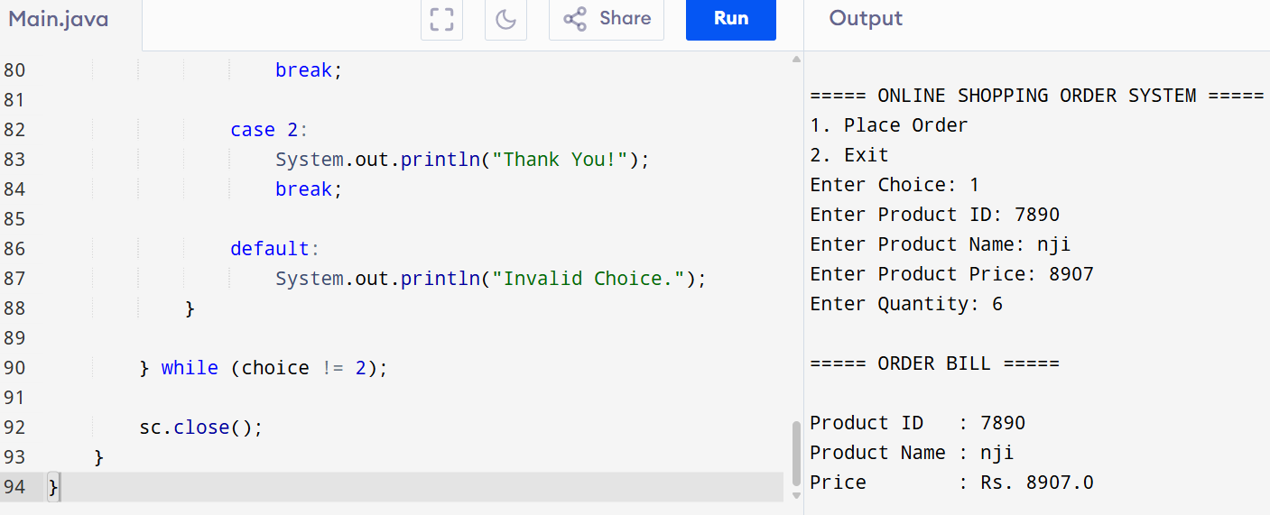
9. Student Result Analyzer using Arrays of Objects
import java.util.Scanner;

class Student {
private int rollNo;
private String name;
private int mark1, mark2, mark3;
private int total;
private double average;
private String grade;

public Student(int rollNo, String name, int mark1, int mark2, int mark3) {
this.rollNo = rollNo;
this.name = name;
this.mark1 = mark1;
this.mark2 = mark2;
this.mark3 = mark3;
calculateResult();
}

public void calculateResult() {
total = mark1 + mark2 + mark3;
average = total / 3.0;

if (average >= 90)
grade = "A+";
else if (average >= 80)
grade = "A";
else if (average >= 70)
grade = "B";
else if (average >= 60)
grade = "C";
else if (average >= 50)
grade = "D";
else
grade = "F";
}

public int getTotal() {
return total;
}

public void display() {
System.out.println("\n===== STUDENT DETAILS =====");
System.out.println("Roll Number : " + rollNo);
System.out.println("Name : " + name);
System.out.println("Marks : " + mark1 + ", " + mark2 + ", " + mark3);
System.out.println("Total : " + total);
System.out.printf("Average : %.2f\n", average);
System.out.println("Grade : " + grade);
}
}

public class Main {

public static void main(String[] args) {

Scanner sc = new Scanner(System.in);

Student[] students = new Student[100];
int count = 0;
int choice;

do {
System.out.println("\n===== STUDENT RESULT ANALYZER =====");
System.out.println("1. Add Student");
System.out.println("2. Display All Students");
System.out.println("3. Display Class Topper");
System.out.println("4. Exit");
System.out.print("Enter Choice: ");
choice = sc.nextInt();

switch (choice) {

case 1:
System.out.print("Enter Roll Number: ");
int roll = sc.nextInt();
sc.nextLine();

System.out.print("Enter Student Name: ");
String name = sc.nextLine();

System.out.print("Enter Marks in Subject 1: ");
int m1 = sc.nextInt();

System.out.print("Enter Marks in Subject 2: ");
int m2 = sc.nextInt();

System.out.print("Enter Marks in Subject 3: ");
int m3 = sc.nextInt();

students[count++] = new Student(roll, name, m1, m2, m3);

System.out.println("Student Added Successfully.");
break;

case 2:
if (count == 0) {
System.out.println("No Student Records Found.");
} else {
for (int i = 0; i < count; i++) {
students[i].display();
}
}
break;

case 3:
if (count == 0) {
System.out.println("No Student Records Found.");
} else {
int topperIndex = 0;

for (int i = 1; i < count; i++) {
if (students[i].getTotal() > students[topperIndex].getTotal()) {
topperIndex = i;
}
}

System.out.println("\n===== CLASS TOPPER =====");
students[topperIndex].display();
}
break;

case 4:
System.out.println("Thank You!");
break;

default:
System.out.println("Invalid Choice.");
}

} while (choice != 4);

sc.close();
}
}
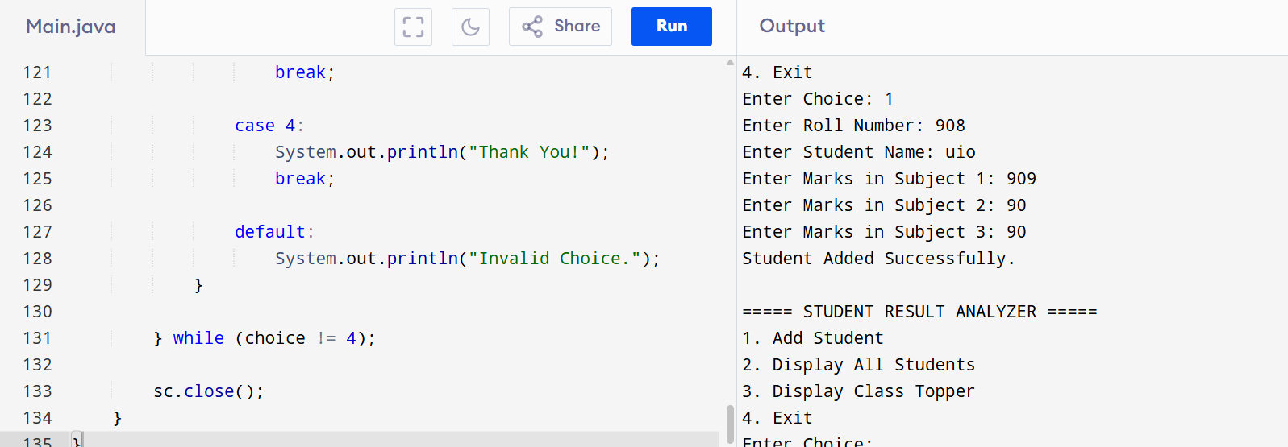

10. Smart Home Device Controller using Hierarchical Inheritance
import java.util.Scanner;

// Base Class
class Device {
protected String deviceName;
protected boolean status;

public Device(String deviceName) {
this.deviceName = deviceName;
this.status = false;
}

public void turnOn() {
status = true;
System.out.println(deviceName + " is ON");
}

public void turnOff() {
status = false;
System.out.println(deviceName + " is OFF");
}

public double powerConsumption() {
return 0;
}

public void display() {
System.out.println("\nDevice Name : " + deviceName);
System.out.println("Status : " + (status ? "ON" : "OFF"));
System.out.println("Power Consumption : " + powerConsumption() + " Watts");
}
}

// Light Class
class Light extends Device {

public Light(String deviceName) {
super(deviceName);
}

@Override
public double powerConsumption() {
return 20;
}
}

// Fan Class
class Fan extends Device {

public Fan(String deviceName) {
super(deviceName);
}

@Override
public double powerConsumption() {
return 75;
}
}

// AirConditioner Class
class AirConditioner extends Device {

public AirConditioner(String deviceName) {
super(deviceName);
}

@Override
public double powerConsumption() {
return 1500;
}
}

// Main Class
public class Main {

public static void main(String[] args) {

Scanner sc = new Scanner(System.in);

Device[] devices = new Device[20];
int count = 0;
int choice;

do {
System.out.println("\n===== SMART HOME DEVICE CONTROLLER =====");
System.out.println("1. Add Light");
System.out.println("2. Add Fan");
System.out.println("3. Add Air Conditioner");
System.out.println("4. Turn ON Device");
System.out.println("5. Turn OFF Device");
System.out.println("6. Display Devices");
System.out.println("7. Exit");
System.out.print("Enter Choice: ");
choice = sc.nextInt();
sc.nextLine();

switch (choice) {

case 1:
System.out.print("Enter Light Name: ");
devices[count++] = new Light(sc.nextLine());
System.out.println("Light Added Successfully.");
break;

case 2:
System.out.print("Enter Fan Name: ");
devices[count++] = new Fan(sc.nextLine());
System.out.println("Fan Added Successfully.");
break;

case 3:
System.out.print("Enter Air Conditioner Name: ");
devices[count++] = new AirConditioner(sc.nextLine());
System.out.println("Air Conditioner Added Successfully.");
break;

case 4:
if (count == 0) {
System.out.println("No Devices Available.");
break;
}

System.out.print("Enter Device Number (1-" + count + "): ");
int on = sc.nextInt();

if (on >= 1 && on <= count)
devices[on - 1].turnOn();
else
System.out.println("Invalid Device Number.");
break;

case 5:
if (count == 0) {
System.out.println("No Devices Available.");
break;
}

System.out.print("Enter Device Number (1-" + count + "): ");
int off = sc.nextInt();

if (off >= 1 && off <= count)
devices[off - 1].turnOff();
else
System.out.println("Invalid Device Number.");
break;

case 6:
if (count == 0) {
System.out.println("No Devices Available.");
} else {
System.out.println("\n===== DEVICE DETAILS =====");
for (int i = 0; i < count; i++) {
System.out.println("\nDevice " + (i + 1));
devices[i].display(); // Runtime Polymorphism
}
}
break;

case 7:
System.out.println("Thank You!");
break;

default:
System.out.println("Invalid Choice.");
}

} while (choice != 7);

sc.close();
}
}
